BATCATS IN VIETNAM
The aircraft of the 553rd Reconnaissance Wing

The 553rd Reconnaissance Wing organized on Feb. 25, 1967 at Otis AFB, Mass. The official designation given to the organization was misleading at best. The 553rd was not a traditional reconnaissance wing; in fact the organization had no aerial photography equipment. The unit was specifically activated to fly one of the most unique missions during the Vietnam War. The wing was responsible for monitoring and relaying troop activity along the Ho Chi Minh trail. Utilizing seismic and acoustic sensors to detect enemy ground forces, crews continuously monitored the Ho Chi Minh Trail 24 hours a day in support of anti-infiltration operations. The program was originally named PRACTICE NINE; the name later changed to IGLOO WHITE.

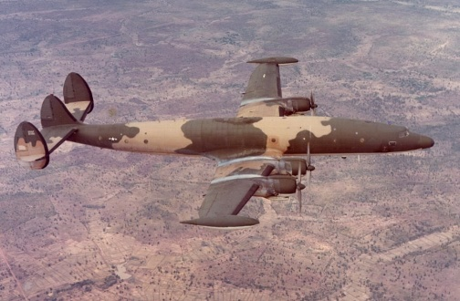
The Lockheed C-121 Super Constellation was chosen as the base platform for the mission. The operational plan specified that 30 former Navy EC-121K aircraft would be acquired from the bone yard at Davis Monthan AFB. The aircraft were prepared for a one-time flight to Ontario California for modifications to the EC-121R standard. Once the Primary mission equipment was installed, the aircraft and crews participated in multiple tests to evaluate the system before deploying to Southeast Asia. The EC-121R (call sign Batcat) performed exceptionally well both in training and in its initial combat operations. The need for a follow on aircraft was not driven by the EC-121Rs performance. One reason a new aircraft was being looked at dealt with the size of a EC-121R crew. Each EC-121R had a crew of at least 18 people; it was not uncommon for a crew to be even larger depending on the mission profile. EC-121R missions put a large crew at risk over hostile territory.
The 553rd RW’s, two flying squadrons operated Lockheed EC-121R Super Constellations.

On September 1967, the Defense Communication Planning Group (DCPG) tasked the USAF to procure an aircraft that could perform IGLOO WHITE missions in high anti-aircraft artillery/surface to air missile threat areas. After multiple aircraft were considered, the DCPG directed the USAF to develop and test modified Beechcraft Debonairs (Model 33) for the role. Later designated YQU-22A Pave Eagle I, the single engine aircraft were required to have a communication data link to allow the aircraft to report sensor activity from 165 miles away from an altitude of 24,000 feet. The aircraft utilized a drone guidance system, an IFF set, and an oxygen system to allow the aircraft the capability to be flown manually. The Beechcraft Company was awarded the contract in February 1968, with subcontracts awarded to Univac and Radiation Inc for the relay equipment and primary mission equipment.

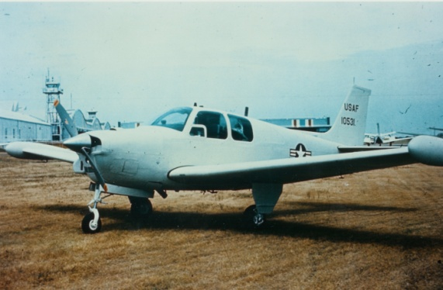
Stateside testing of the Pave Eagle I was accomplished in multiple phases. Beechcraft evaluated the aircraft’s performance with the additional modifications in Wichita, while the primary mission equipment and aircraft PME flight tests were performed at Eglin AFB, Fla. The in-theater evaluation of the aircraft was to be conducted by the 553rd Reconnaissance Wing stationed at Korat Thailand. The 553rd RW initial role in the Pave Eagle I program had been limited to an advisory capacity since the wing’s two flying squadrons, the 553rd and the 554th had vast experience with conducting IGLOO WHITE operations. On Oct. 8, 1968 the wing’s role would change: Headquarters PACAF informed the 553rd RW that they would be assigned command responsibility for testing the Pave Eagle I in theater.
The first YQU-22A built, tail # 68-10531, was destroyed after experiencing an engine failure over Laos.

The subordinate unit organized to test the Pave Eagle system was named Detachment 1; the detachment was officially assigned to the 553rd RW on Nov. 30, 1968, stationed at Nakon Phanom Thailand with five YQU-22As on strength. The detachment (known as the Vampires) assembled the five aircraft from crates and performed flight checks on each aircraft. After the YQU-22As were declared operational, the Vampires flew simulated orbits around Nakon Phanom, testing the aircraft’s communication data link equipment. On Jan. 9, 1969, the Pave Eagles were tested on three orbits usually flown by the wings EC-121R aircraft. The field tests also compared the Pave Eagle performance to that of the EC-121R Speckled Bug aircraft. On Feb. 5, 1969, the 553rd RW submitted their final report on the initial Pave Eagle I program to PACAF Headquarters. The report stated that the YQU-22A performed to a satisfactory level, but did not perform as predicted. All flights were manned, and take off and landings were flown manually due to runway issues at NKP. After take off the aircraft were flown in “drone mode”. It took over two hours for the YQU-22A to reach its desired operating altitude of 24,000 feet. Once at altitude the aircraft’s performance was seriously degraded.

The orbital tests provided better results: the aircraft could perform its desired track up to 150 miles from the controlling equipment. The primary mission equipment performed well and comparisons between the YQU-22A and EC-121R demonstrated that the single engine Beech could perform 80 percent of the mission capabilities of the EC-121R. The success of the primary mission equipment during the tests would have a direct impact on the 553rd RW. On 1 March 1969, Detachment 1 became combat ready and began flying two back to back four hour combat sorties over Red Orbit in support of COMMANDO HUNT operations. YQU-22A’s covered missions flown by 553rd EC-121R aircraft, allowing the wing to establish a new EC-121R orbit. Pilots of Detachment 1 flew a total of 62 combat missions in March 1969, with an overall mission effectiveness of 92 percent.

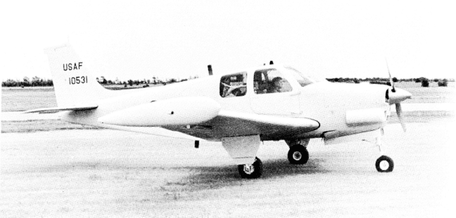
After March 1969, Detachment 1 suffered multiple setbacks to the Pave Eagle I program. The Southwest monsoon season significantly affected the operational effectiveness of the system. The YQU-22A could not operate in clouds above the freezing level since the YQU-22A did not have de-icing equipment. On April 8 an YQU-22A serial 68-10533 was involved in a gear-up landing accident. Three months later the Pave Eagle program experienced its first loss of an aircraft over Laos. On June 11 a YQU-22A 68-10531 experienced an engine failure over hostile territory, the pilot assumed manual control of the aircraft and attempted to restart the engine 12 times unsuccessfully. The pilot bailed out at 1700 feet, with the YQU-22A spiraling into the ground, an A-1 Skyraider from the 1st Special Operations Squadron was tasked to make sure the aircraft was completely destroyed; the pilot spent 35 minutes in enemy territory before being rescued by a HH-3E Jolly Green Giant. The YQU-22A suffered three engine failures in flight with two engines successfully restarted and one not, leading to the crash of 68-10531. The incidents and operational issues did not go unnoticed, Gen. Joseph Nazzarro CINCPACAF, requested a study on YQU-22A operations. The study produced by the 553rd RW, revealed significant shortcomings to the program. The study recommended downgrading the YQU-22A from operational status to test status and returning the program back to the states. The study also recommended not procuring the QU-22B Pave Eagle II.
The YQU-22A’s generator and tip tanks are visible in this photograph. The lack of de-icing equipment is also apparent.

The unexplained engine failures continued to plague the program. Combat missions for all Pave Eagle I aircraft were suspended indefinitely on July 1, 1969. In August a second YQU-22A (68-10532) aircraft was lost when the aircraft experienced an engine failure; the pilot attempted to make an approach to an unused field but failed to reach the strip and the civilian pilot was killed in the ensuing crash. The 553rd RW took action and grounded all YQU-22A aircraft. On Sept. 1, 1969 Detachment 1 was ordered to redeploy to Eglin AFB, Fla, on Oct. 20 the USAF ending the Pave Eagle I program.

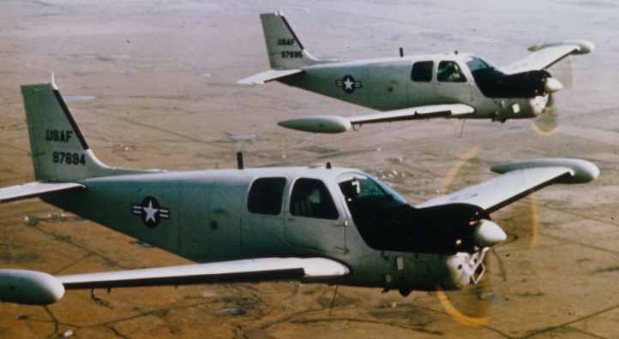
The 553rd Reconnaissance wing would be directed to evaluate and develop procedures for the follow on aircraft the QU-22B Pave Eagle II. The QU-22B was a modified Beechcraft (Model A36) Bonanza, giving the aircraft better performance characteristics than the YQU-22A. The aircraft was powered by a Continental GTSIO-520-G engine rated at 375 horse power. A generator was located directly above the engine to power associated electronic equipment. Unlike the YQU-22A, the Pave Eagle II incorporated de-icing equipment which allowed the aircraft to operate at altitudes above 25 thousand feet. The aircraft had a maximum speed of 204 mph and a loiter time of six hours when manned, 10 hours in drone configuration.
The QU-22B could be visibly distinguished from the earlier “A” models by the large generator positioned above the engine giving the aircraft a noticeable hump.

Detachment 1 was activated once again at Nakhon Phanom Royal Thai AFB on March 31, 1970. The mission of Detachment 1 was to complete the theater evaluation of the QU-22Bs primary mission equipment. The operation changed to a joint operation between the 553rd RW and the 56th Special Operations Wing stationed at NKP. The 553rd would be assigned the aircraft, provide aircrews and provide flight line maintenance. The 56th SOW would support field and avionics maintenance and the normal base support. One of the objectives of the Pave Eagle II program was to replace the aging EC-121R. The USAF’s cost comparison estimated the new program would save $13.1 million annually. The detachment started with five QU-22B aircraft that arrived between June 7-9, 1970. The QU-22Bs (nicknamed the mini-bat or baby-bat) were uncrated and assembled at NKP.

The detachment became operational in June and the first evaluation missions for the QU-22B began. In August the wing was granted permission to begin Pave Eagle II missions over Laos. The evaluation period was completed on 10 September; a final report was submitted by the 553rd RW. The findings in the report confirmed that the QU-22B weapon system successfully completed the evaluation and was ready to assume the EC-121Rs sensor data relay mission in support of IGLOO WHITE. The wing started the process to scale back EC-121R operations as the QU-22B came online. Detachment 1 started combat operations on Oct. 1, 1970. The unit was responsible for ten hours over a specific orbit. With an increase in operations the 553rd requested that three additional QU-22B “Mini Bats” be deployed to NKP.

With the numbers of QU-22B on the rise, the opposite was happening with the wing’s EC-121R. The 553 RW’s plan to phase out the EC-121R was ahead of schedule. Although the Mini-Bats had only been declared combat operational since 1 October, they boasted impressive numbers during the last quarter of 1970. They achieved an on station effectiveness rate of 98.2 percent in support of IGLOO WHITE operations. The 553rd had a total of 16 operational QU-22B aircraft during December 1970. The initial success of the QU-22B ultimately eliminated the 553rd RW as an organization. With the large crews no longer needed to perform EC-121R missions, there was no need to have a wing organization. The 553rd Reconnaissance Wing inactivated on Dec. 15, 1970. Detachment 1 was redesignated the 554th Reconnaissance Squadron and fell under control of the 56th Special Operations Wing.

Reliability issues with the QU-22B surfaced soon after the wing had been inactivated. On Feb. 8, 1971, a QU-22B from the 554th RS experienced an engine failure; the ensuing crash killed the pilot. The QU-22B suffered three additional engine failures and one control failure due to turbulence that resulted in combat losses during 1972. The last engine failure incident occurred on Aug. 25, 1972 killing the pilot, 1st Lt. Lanny Allen York. The QU-22B was eventually pulled from service, ironically the surviving airframes found their way to the bone yard at Davis Monthan.

